Experiment no. 11

Aim: To study the CORBA Architecture.
Theory:
Common Object Request Broker Architecture (CORBA) could be a specification of a regular design for middleware. It is a client-server software development model.
Using a CORBA implementation, a shopper will transparently invoke a way on a server object, which may air a similar machine or across a network. The middleware takes the decision, associated is to blame for finding an object that will implement the request, passing it the parameters, invoking its methodology, and returning the results of the invocation. The shopper doesn’t need to remember wherever the item is found, its programming language, its software package or the other aspects that don’t seem to be a part of the associated object’s interface.
CORBA Reference Model:
The CORBA reference model known as Object Management design (OMA) is shown below figure. The OMA is itself a specification (actually, a group of connected specifications) that defines a broad variety of services for building distributed client-server applications. Several services one may expect to search out in a very middleware product like CORBA (e.g., naming, dealings, and asynchronous event management services) are literally fixed as services within the OMA
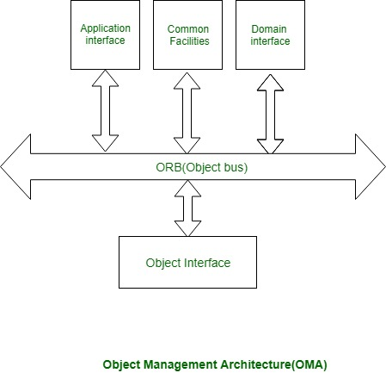
CORBA Reference Model
Different parts communicate victimization ORB. ORB is additionally referred to as the item bus. An associate example of the application interface is a distributed document facility. In a very domain interface, it will have domain dependent services, for instance, producing domain.
Object interface has some domain freelance services:
- Naming_Service:
Naming service is additionally known as a white page service. Victimization naming service server-name will be searched, and its location or address pointed out.
- Trading_Service:
Commercialism service is additionally known as a yellow page service. Victimization commercialism service a selected service will be searched. This is often corresponding to looking out a service like an automobile store in a very yellow page directory.
The Broker pattern is particularly useful in helping you follow these design principles:
- Divide and conquer. The remote objects can be independently designed.
- Increase reusability. It is typically possible to design the remote objects so that other systems can use them too.
- Increase reuse. You may be able to reuse remote objects that others have created.
- Design for flexibility. The broker objects can be updated as required, or you can redirect the proxy to communicate with a different remote object.
- Design for portability. You can write clients for new platforms while still accessing brokers and remote objects on other platforms.
- Design defensively. You can provide careful assertion checking in the remote objects.
CORBA is a specification defined by the Object Management Group (OMG) that is currently the most widely used middleware in most distributed systems. It allows systems with diverse architectures, operating systems, programming languages, and computer hardware to work together. It allows software applications and their objects to communicate with one another. It is a standard for creating and using distributed objects. It is made up of five major components. Components and their function are given below:
- Object Request Broker (ORB): It provides a communication infrastructure for the objects to communicate across a network.
- Interface Definition Language (IDL): It is a specification language used to provide an interface in a software component. To exemplify, it allows communication between software components written in C++ and Java.
- Dynamic Invocation Interface (DII): Using DII, client applications are permitted to use server objects without even knowing their types at compile time. Here client obtains an instance of a CORBA object and then invocation requests can be made dynamically on the corresponding object.
- Interface Repository (IR): As the name implies, interfaces can be added to the interface repository. The purpose of IR is that a client should be able to find an object which is not known at compile-time and information about its interface then request is made to be sent to ORB.
- Object Adapter (OA): It is used to access ORB services like object reference generation.
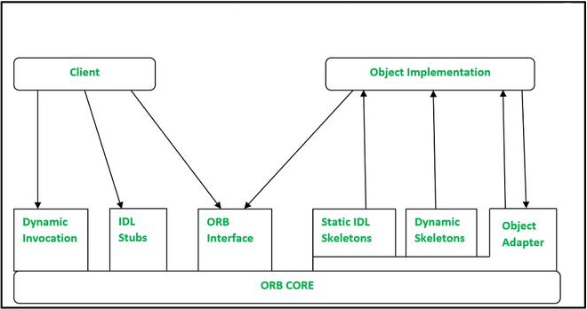
Data Representation in CORBA:
Common Data Representation (CDR) is used to describe structured or primitive data types that are supplied as arguments or results during remote invocations on CORBA distributed objects. It allows clients and servers’ built-in computer languages to communicate with one another. To exemplify, it converts little-endian to big-endian.
There are 15 primitive types: short (16-bit), long (32-bit), unsigned short, unsigned long, float (32-bit), double (64-bit), char, boolean (TRUE, FALSE), octet (8-bit), and any (which can represent any basic or constructed type), as well as a variety of composite types.
CORBA CDR Constructed Types:
Let’s have a look at Types with their representation:
- sequence: It refers to length (unsigned long) to be followed by elements in order
- string: It refers to length (unsigned long) followed by characters in order (can also have wide characters)
- array: The elements of the array follow order and length is fixed so not specified.
- struct: in the order of declaration of components
- enumerated: It is unsigned long and here, the values are specified by the order declared.
- union: type tag followed by the selected member
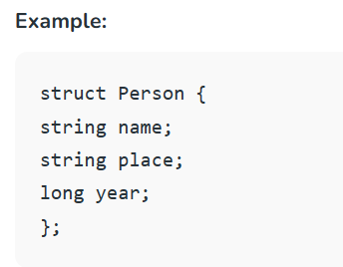
Marshalling CORBA:
From the specification of the categories of data items to be transmitted in a message, Marshalling CORBA operations can be produced automatically. CORBA IDL describes the types of data structures and fundamental data items and provides a language/notation for specifying the types of arguments and results of RMI methods.
Conclusion: In conclusion, CORBA provides a standardized framework for enabling communication between distributed objects across diverse systems, supporting different programming languages and platforms. It achieves interoperability through components like ORB, IDL, and CDR, ensuring seamless client-server interactions in a heterogeneous computing environment.

